Please Give to the Washington Fund

The Washington Fund is the first of annual fundraising events. This money covers important programs not covered by public school funding such as classroom grants for teachers, anti-bullying counselling, poetry, assemblies and P.E. with the fabulous Coach Don.

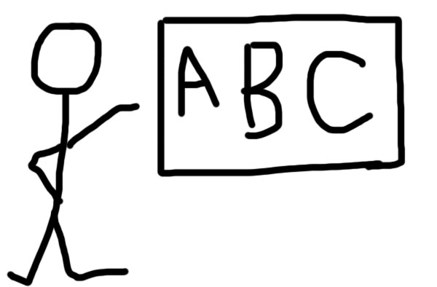
The 2022/23 PTA budget is approximately $500 per student.
Classroom Support!

Art Supplies!
Community Events!
P.E.!

How do I donate?
Go to the Washington website at www.washington.berkeleypta.org and click on the “Give to the Washington Fund” button. If you’d prefer to write a check or give cash, please fill out the form on the opposite side and put it in the black PTA mailbox in the front office or send it to school in your child’s homework folder.

How much should I donate?
If you can give $500, thank you! If you can afford a little (or a lot) more, you will offset the cost for a family who cannot. Please know that every single dollar is helpful!

Kindergarten families: a useful guideline is to give the same amount you would have spent on one month’s tuition for preschool or childcare. What a bargain!

Washington PTA is a 501(c)3 not for profit organization; all donations are tax deductible. The tax ID number for the Washington PTA is 94-6174706.

Questions? Please contact David Moren at: ptaofficers@googlegroup.com

Ask your employer about Employee Donation
Matching!
Our Benevity ID - 946174706
Yes! I will contribute to the Washington Fund!

Please complete the information and return this form to the Washington PTA mailbox in the main office or send it to school in your child’s homework folder.

To set up an automatic monthly donation or to pay by PayPal, credit or debit card, please visit www.washington.berkeleypta.org/donate.

Parent/Guardian Name(s):______________________________________________
Address: ____________________________________________________________
Email: _______________________________ Phone: _____________________
Child 1:___________________________ Grade: ________ Teacher: _____________
Child 2: ___________________________ Grade: ________ Teacher: _____________
Child 3: ___________________________ Grade: ________ Teacher: _____________
Thank you!

Donation Amount $_______________

Attach cash or check made out to Washington PTA and return to the PTA mailbox in the main office, or mail it to:
Washington PTA
2300 Martin Luther King Jr Way
Berkeley, Ca 94704-1480

You can make recurring donations as often as you like during the course of the year. Use the Donate button on the Washington website, or put your donation in an envelope marked “Washington Fund” with your name, your child’s name and their teacher’s name, and place it in the PTA mailbox in the front office.

Washington staff and students
thank you for your contribution!

